MACH4METAL

metalworking machinery
Transito 21, 6909 DA Babberich, Netherlands
Tel. + 31 (0)316 – 247123
Fax. + 31 (0)316 - 247956
info@mach4metal.com
www.mach4metal.com
Bank No : 66.52.13.883
IBAN : NL33 INGB 0665 2138 83
BIC : INGBNL2A
VAT : NL 815393635B01

MAZAK QTN 100

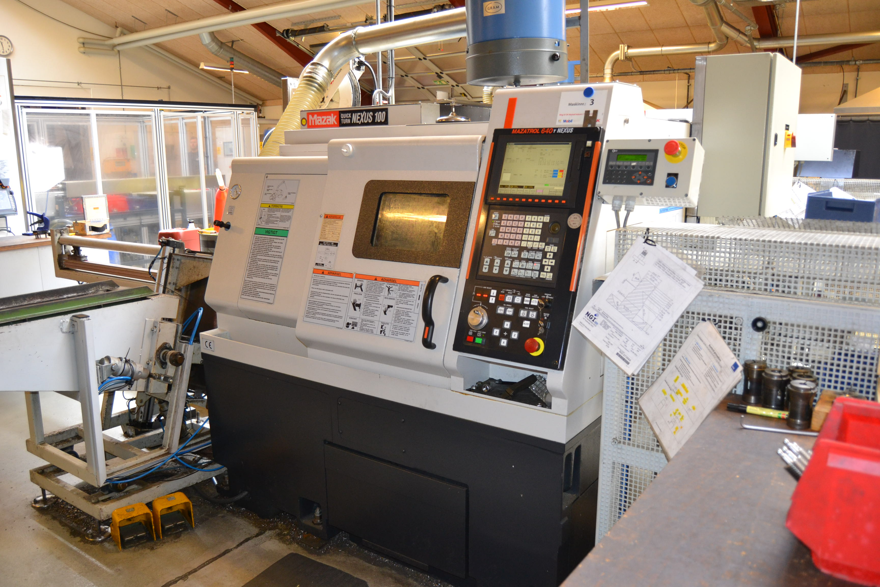
- Make : MAZAK
- Type : QTN 100
- Serial :
- YOP : 2006

- Max. swing Ø : 550
- Machining swing Ø : 280
- DBC turning length : 309

- Spindle bore : 51
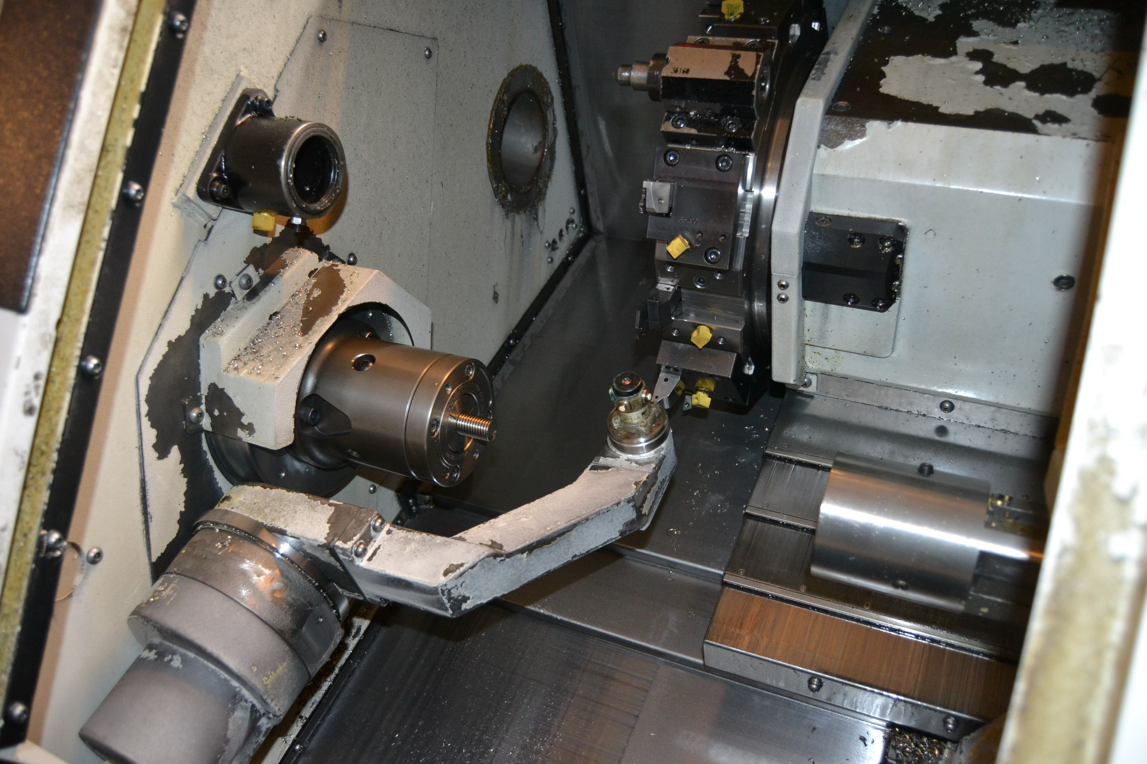
- X travel : 190
- Z travel : 330
- Spindle speed : 4.500

- ATC revolver : 12 positions
- Live tooling speed : 4.500 Rpm
- Sub spindle stroke : 5 Gr
- Sub spindle speed : 4.000 Rpm

- Feed rate X/Z : 30.000 mm/M
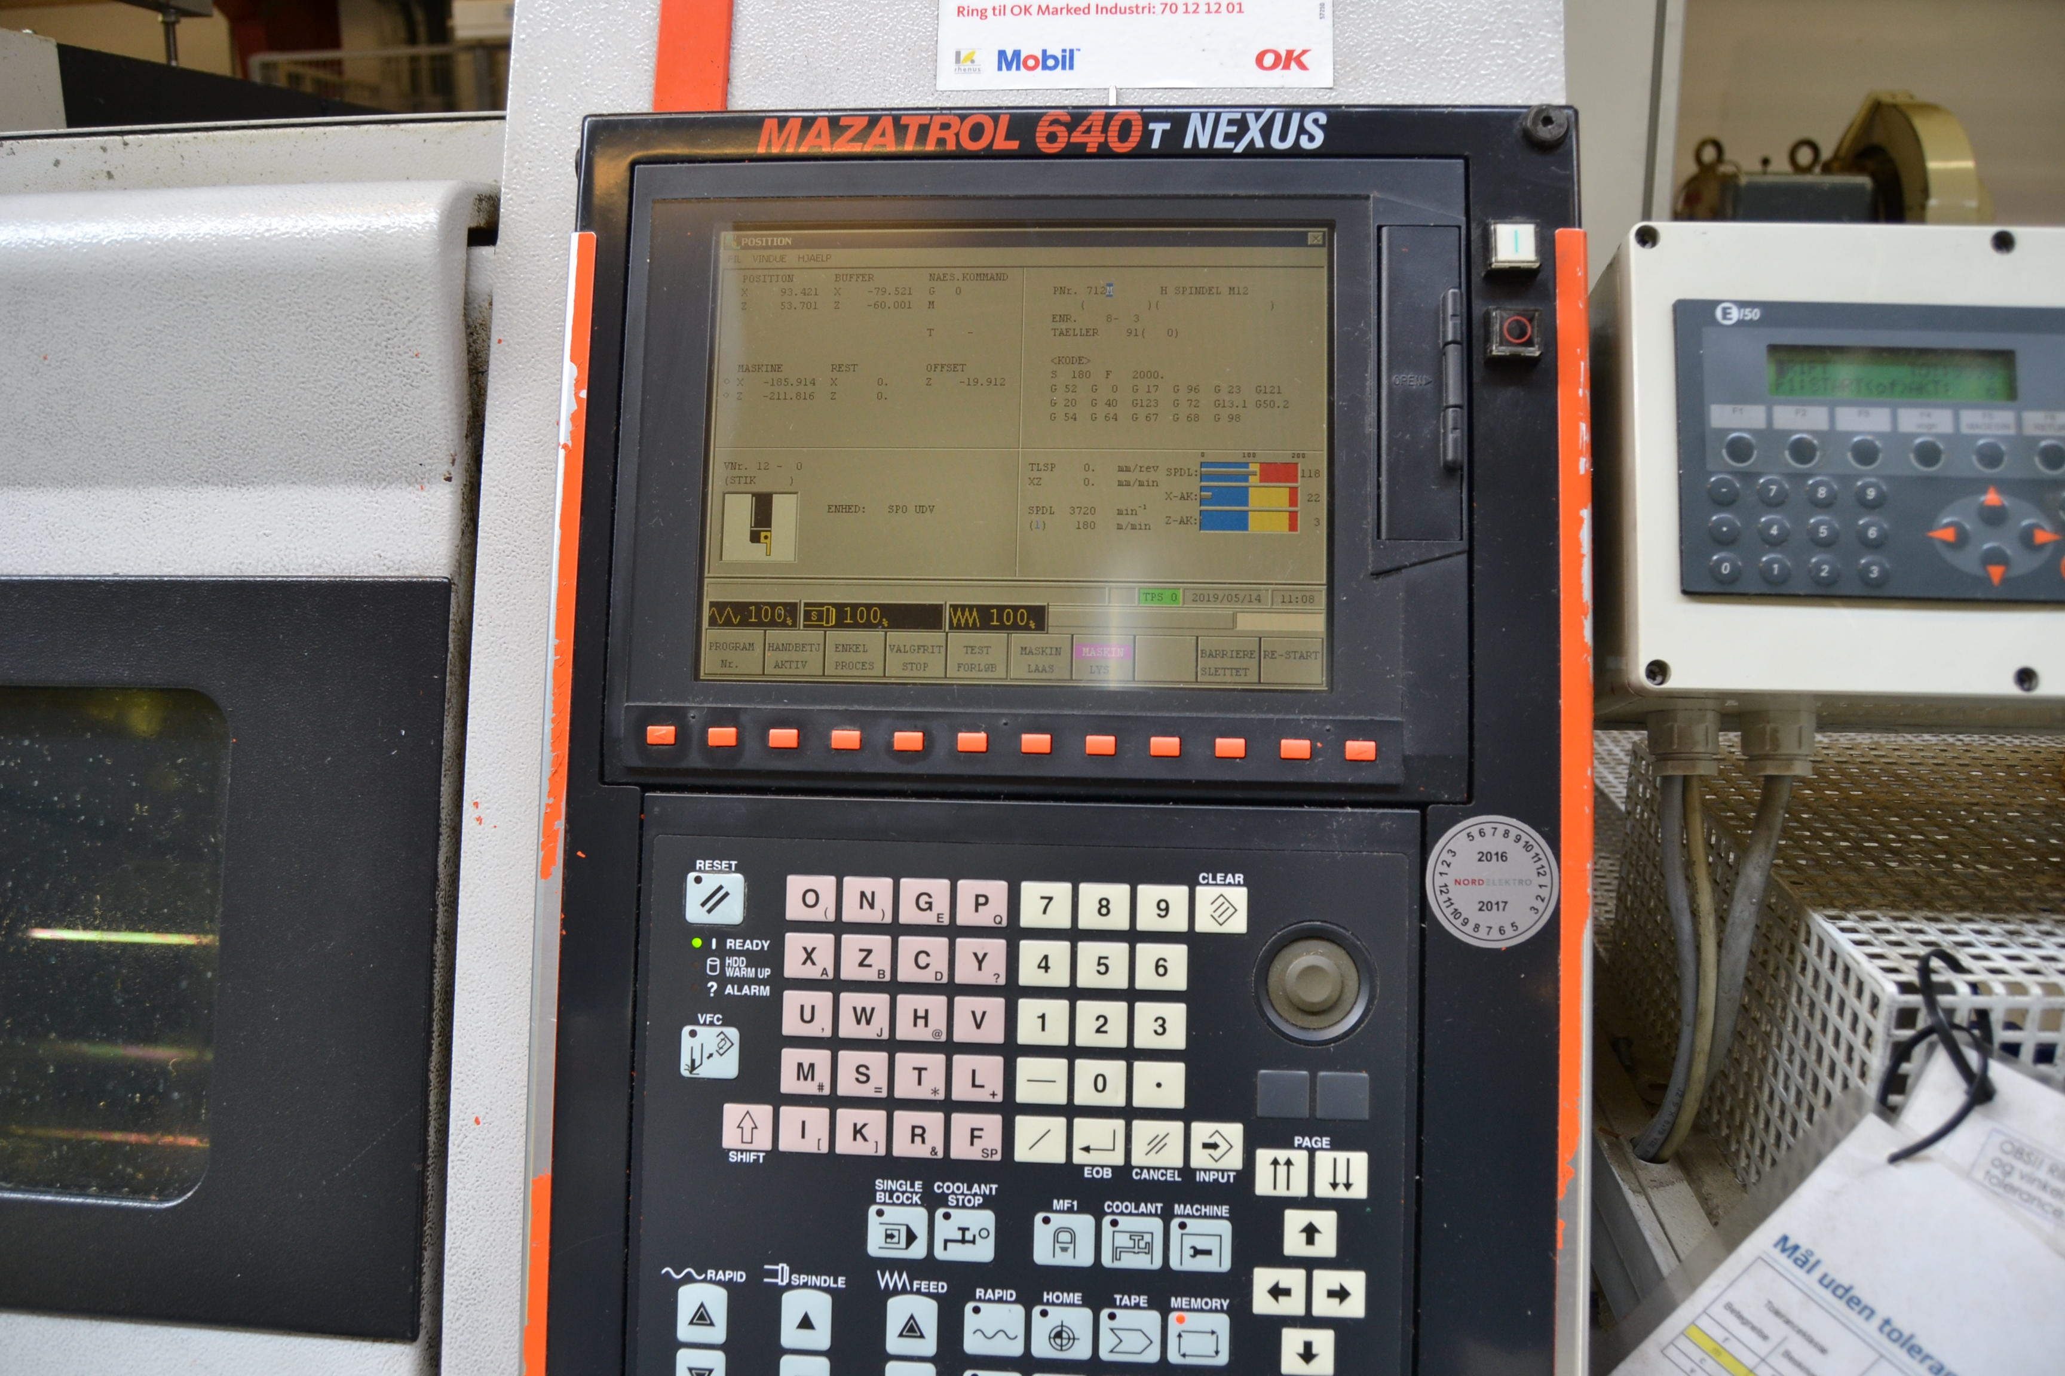
- Tail stock pinole : Mk 4
- Tail stock travel : 350

- CNC MAZATROL Nexus 640 T
- Chip conveyor
- Tool pre setter

- Dimensions
- Length : 2650
- Width : 2000
- Height : 1800
- Weight : 3500
- Power : 11 KW

Please Note: The above information has been obtained to the best of our ability and belief from, and from the manufacturers where possible. It is given in good faith, but its accuracy can not be guaranteed. Accordingly, it will not form a representation or constitute contractual terms. We advise you to check any vital details

